SWE201c 🡪 SWT SWR 🡪 kì 5

Students should read the following situation carefully: **Retake SU23**

The Covid pandemic has gone, but the ABC company wants to keep the hybrid work. Therefore, a human  
resource department manager desires a software product to ensure employees work remotely efficiently  
and effectively. Remote work management refers to the processes and tools used to ensure that employees  
work remotely, in which training and support module is essential. A list of features that a training and  
support system for employees in Web application include:

**✓ Training courses:** The system should offer a library of training courses that **employees can take to  
improve their skills and knowledge.  
✓ Course catalog:** The system should provide a catalog of available training courses with detailed  
descriptions, prerequisites, and recommended audiences.  
**✓Course schedule:** The system should **allow** **employees** to **enroll in upcoming training courses and  
provide information about course dates, times, and locations.  
✓Course delivery:** The system should offer multiple modes of course delivery, including online,  
classroom, and self-paced.  
**✓Course assessments:** The system should provide evaluations for each course, including quizzes and  
exams, to measure employee progress and understanding. **(Business req)**  
**✓ Training records:** The system should track employee training records, including courses taken,  
completion dates, and results.   
**✓ Performance tracking:** **The system should allow** **managers** to **track employee performance before**  
and **after training courses to measure the impact of training on employee performance**.  
**✓Feedback and surveys:** **The system should allow** **employees** to **provide feedback on training courses**  
and **managers** to **collect feedback through surveys and other mechanisms**.  
**✓Skill assessments:** The system should provide(Admin) assessments for employee skills, such as technical or soft skills, to identify areas for improvement. **✓ Support resources:** The system should offer support resources, such as documentation and online  
forums, to help employees apply their training and overcome obstacles.

* **employees** to **enroll in upcoming training courses and provide information about course dates, times, and locations.**
* **managers** to **track employee performance before** and **after training courses to measure the impact of training on employee performance**.
* **employees** to **provide feedback on training courses**
* **managers** to **collect feedback through surveys and other mechanisms**.

Assume you are a product owner in this project and lead the team working on this project consisting of  
**6 developers and 2 QA**. The organization supplies requirements and additional resources at the  
beginning of the project and not long-term support.

**Please answer these questions:**

1. What **software development methodology** would you suggest for this situation and why?  
(3 points)

- Identifying the characteristics of this situation and specifying the logic behind the selection of  
characteristics

-Select a model that best fits the factors you identified above.

Agile

2. List **four functional requirements** and **two non-functional requirements** for which **you want to apply the above project**. (1.5 points).

Usability: web site than thiện… css đẹp..

* four functional requirements (yêu cầu chắc năng) **con người tác động đến phần mềm** -> list employee , rating, …
* two non-functional requirements (yêu cầu phi chắc năng) -> **Hệ thống** không phải con người, ví dụ: phải chứa được 100 người cùng 1 lúc, phải bảo mật thông tin cách hàng bằng cách mã hóa mật khẩu, giao diện dễ gần…

3. Write two **user stories** based on your answers in question 2. (1 point)

* **functional requirements.**
* **employees** to **provide feedback on training courses**.
* **As a … , I want to be able to …, So that I can (chém ra…)**

**As a Employees, I want to be able to provide feedback on training courses , so that I can give the manager feedback to improve courses.**

4**. Create a story map** for the **course manager's screen** in the **web app** to show the user experience and  
what you need to build. Feel free to add fictitious functionality and features as you feel appropriate.  
You will be graded on your story map's quality, completeness, and correctness. (2 points).

1 – 2 – 3

1: nâng cấp của cái trước.

2: thêm những chức năng mới.

Story map -> Agile

Login logout view product, product detail (3 tuan phase 1)

Add to cart, view order… (3 tuan phase 2)

Send mail, tích hợp VNPAY sandbox…. (3 tuan phase 3)

+ 9 tuan.

BA -> người đi thu thập yêu cầu khách hang (đi khách)

5. List three assumptions regarding the **course schedule** feature (chất lượng, đường truyền, những thứ liên quan đến chức năng đề bài đặt ra.)

(Liệt kê ba giả định liên quan đến tính năng lịch trình khóa học).

* **chatas luong phải tốt -> High impact if wrong, Low Probability of it being wrong**. 🡪 Explain: tại vì khóa học nó liên quan đến chất lượng nhân viên thế nên công ty sẽ phải chú trọng vào khâu kiểm duyệt về khóa học…
* internet của nhân viên phải tốt: High impact if wrong, High Probability of it being wrong.  
  Explain: nếu internet không tốt thì không thể vào học được và cái chất đi xuống, Probability ->

khóa học được lập lịch cố định (fixed): Low impact if wrong, Low Probability of it being wrong.

* Lịch học sẽ không liên quan đến nhiều về khóa học … và nhân viên được giải lao khi có lịch học và…

Assess the risk of each assumption affecting our product by classifying the assumptions into the following four categories:

High impact if wrong, High Probability of it being wrong.  
High impact if wrong, Low Probability of it being wrong.  
Low impact if wrong, High Probability of it being wrong.  
Low impact if wrong, Low Probability of it being wrong.

Explain why you categorized the assumption into a particular category for each assumption. (1.5 points)

6. What kind of testing would you suggest the team do? (1 point)

1h40p -> link: <https://www.youtube.com/watch?v=aF25KUzjULg&t=6052s>

37p -> link: <https://www.youtube.com/watch?v=wELw-a7oduY>

**Requirements characteristics:**

* Reliability:

Đánh giá system

Và đánh giá requirement

Non-Functional Requirements:

Performance and Scalability: The system should be capable of handling a large number of concurrent users, as well as a growing course catalog, without compromising performance.

Security and Data Privacy: The system must ensure the confidentiality and integrity of employee data and training records. It should comply with relevant data privacy regulations to safeguard sensitive information.

Q5: Ví dụ: 1. Tất cả các khóa học phải có nội dung chính xác …

Assumption 1: Employees will always have reliable internet access to enroll in and participate in online courses. (kết nối mạng)

Risk Assessment: High impact if wrong, High Probability of it being wrong.

Explanation: This assumption is critical to the success of the course schedule feature, as it relies on employees being able to access the system and enroll in online courses. If employees frequently face internet connectivity issues or have unreliable access, it will significantly hinder their ability to participate in online courses, affecting their skill development and productivity. The high probability of this assumption being wrong is due to the various factors that can lead to internet outages or connectivity problems, especially for remote workers who may not always have access to stable internet connections.

Assumption 2: All training courses will have fixed and predefined dates and times for in-person classroom sessions. (có thời gian cố định)

Risk Assessment: Low impact if wrong, High Probability of it being wrong.

Explanation: While having fixed dates and times for classroom sessions can be beneficial for planning and organization, it is possible that unforeseen circumstances may lead to rescheduling or cancelation of certain sessions. However, since this assumption deals with a specific aspect of course scheduling (in-person classroom sessions), the impact of it being wrong is relatively low. It may result in minor inconvenience for employees or require some adjustments in scheduling, but it is not likely to have a significant impact on the overall effectiveness of the training and support system. The high probability of this assumption being wrong is due to the potential for unexpected events or changes in scheduling requirements.

Assumption 3: Employees will actively and promptly provide feedback on training courses and overall training experiences.

Risk Assessment: Low impact if wrong, Low Probability of it being wrong.

Explanation: While gathering feedback from employees is valuable for continuous improvement of the training program, it is not a critical component that directly affects the core functionality of the course schedule feature. The impact of this assumption being wrong is relatively low since not receiving feedback promptly or comprehensively would not hinder employees' ability to access and enroll in courses or participate in training sessions. Moreover, the probability of this assumption being wrong is low because employees are typically encouraged to provide feedback and organizations often use various methods to gather it, such as surveys, periodic check-ins, and open communication channels.

More about non-functional:

Non-functional Requirements:

1. Performance: The system should be responsive and perform efficiently, providing quick access to training materials and resources to ensure a seamless learning experience for employees.

2. Scalability: The system should be able to handle a growing number of users and training courses without a significant decrease in performance, to accommodate the organization's future expansion and evolving training needs.

3. Security: The system should prioritize data security and confidentiality, implementing robust measures to protect employee training records, personal information, and any sensitive data exchanged during the training process.

4. Usability: The system should be user-friendly and intuitive, ensuring that employees and managers can easily navigate through the platform, access training courses, and provide feedback without requiring extensive training or technical expertise.

5. Accessibility: The system should be designed with accessibility standards in mind, catering to employees with different abilities and ensuring that everyone can access and benefit from the training and support resources.

6. Reliability: The system should be highly reliable, with minimal downtime, to ensure that employees can access training materials and resources whenever needed, without interruptions that could hinder productivity or skill development.

7. Compatibility: The system should be compatible with a variety of devices and browsers to allow employees to access training courses and resources from different devices and operating systems.

8. Integration: The system should be capable of integrating with existing HR or learning management systems used by the organization to ensure a smooth flow of data and avoid duplication of efforts in managing employee information and training records.

Waterfall vs Agile

* Waterfall -> 1 cụm requirements -> tốn nhiều tiền, thời gian, nhân công…
* Hiểu rõ requirements, chắc chẳn rằng requirements thay đổi ít hoặc rất ít…
* Sản phảm đã được cố định. SWE -> không dùng
* 1 lần thôi

Agile (hầu hết 99%)

* Agile

12 tháng -> Khách hàng

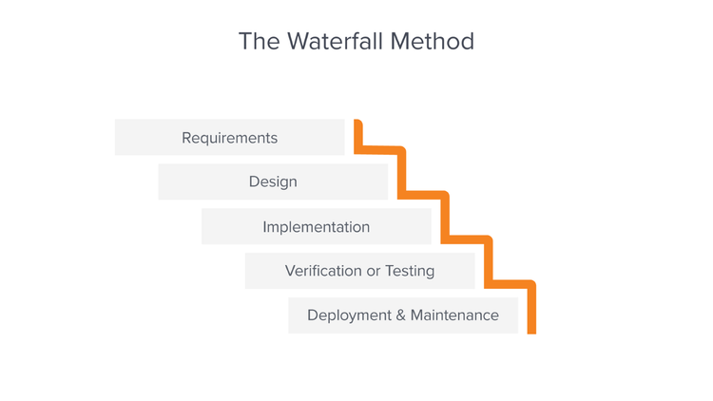

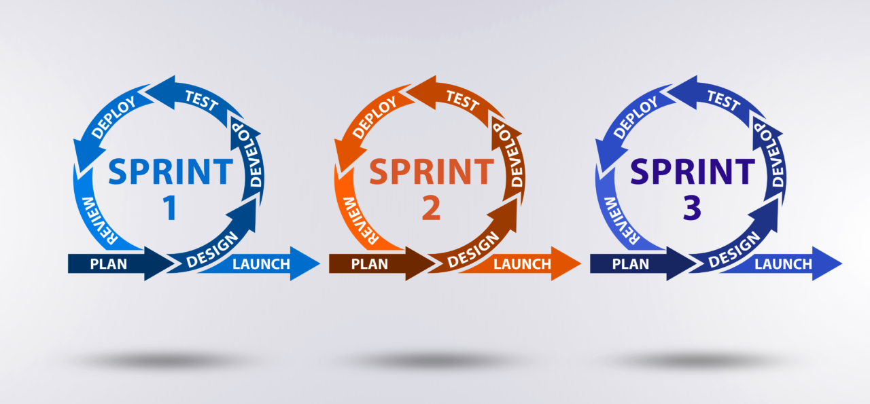

Agile (hầu hết 99%)

* Sản phẩm cuối cùng tốt hơn
* Khách có thể nhìn thấy sản phẩm sớm hơn
* 12-> 3 sprint (4 tháng) -> (thời gian nhất định)

